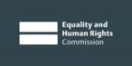

Is Wales Fairer?

Our report about how fair life is
for people in Wales

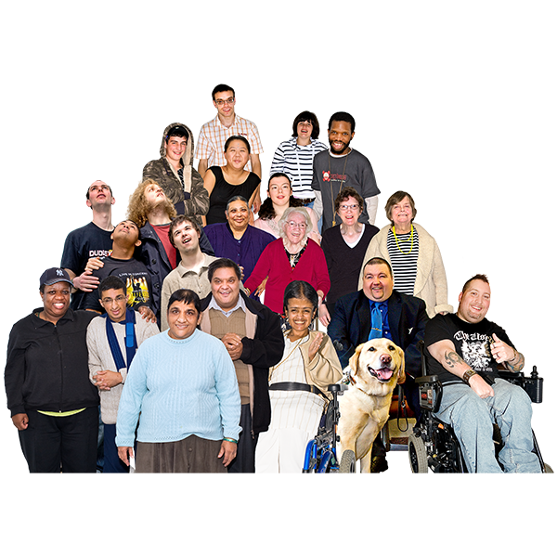

2018

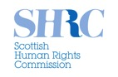
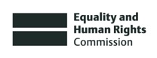
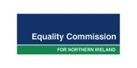

About us

We are called the Equality and Human Rights Commission.

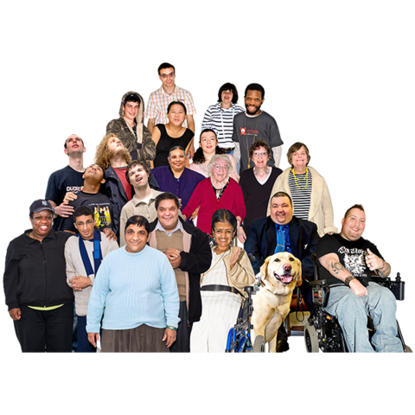
We work to make sure that everyone is treated fairly and gets their human rights.

Human rights are rights that everyone has. Like the right to work, be safe and have a family.

About this report

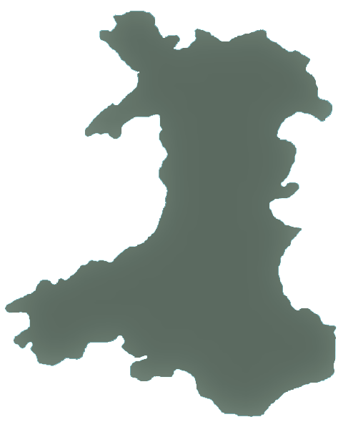
This report is about how fair life is for people in Wales.

We looked at:

- How fair life is for everyone in Wales

- If people are getting their human rights

- What needs to change.

Our last report was in 2015.

We looked at what has happened since then.

What we found out

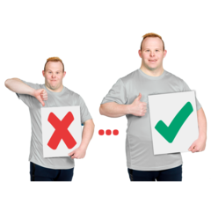

1. Some things have got better

Some things have got better for some people.

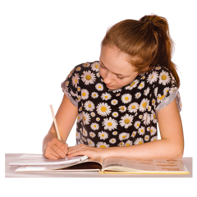
For example, we found that:

- Some children are doing better at school than before

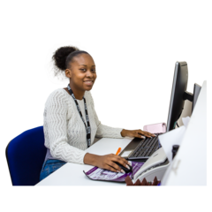
- More women, Indian and Pakistani people are in work

- More women are in jobs that pay more

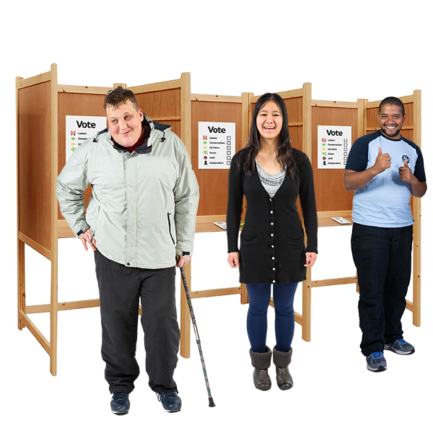
- More people have voted in elections.

Voting is when you choose who to run your local area and country.

For example, more women voted in UK and Wales elections.

2. Life is still unfair for many people
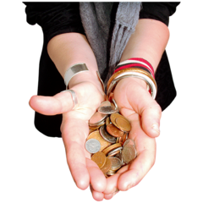

Money

More people are poor and don’t have much money.

More children are poor too.

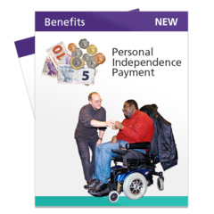
This includes people who need more support, like disabled people.

The rules about tax and benefits have changed.

This is money that people pay to the government or money they get from the government.
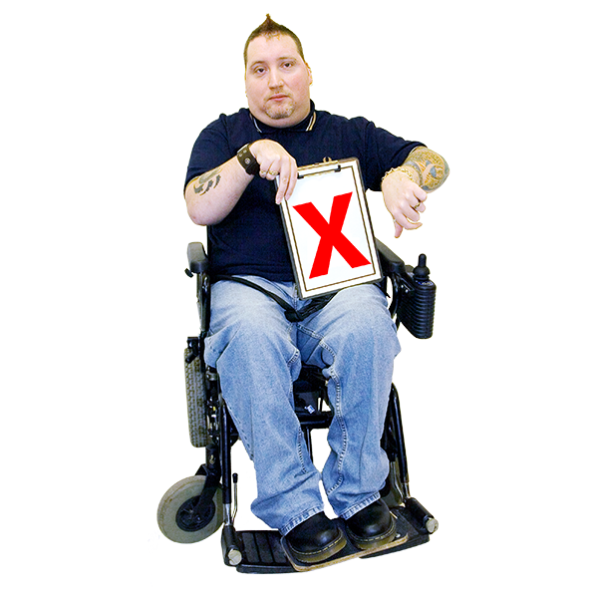

The new rules have made life worse for some groups of people.

For example, disabled people, ethnic minority people, single parents, women and people who don’t earn much money.

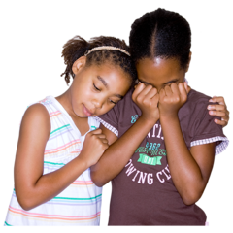
Education

Some groups of children are not doing as well at school.

For example, children from poorer families and children who need extra support with their learning.

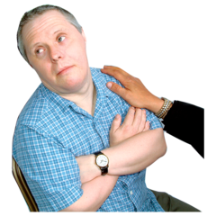

Disabled people

Life has got worse for many disabled people.

For example, some people can’t work because of their disability.

But they have less money from the government to live on.

Disabled people who want to work find it a lot harder to get a job.

They often earn less money when they do get a job.

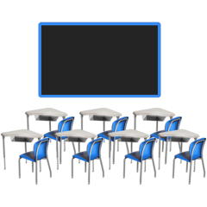
Many children with special education needs and disability are not getting the education they need.

They are also more likely to be taken out of school.

Many disabled people have worse mental health than other people.

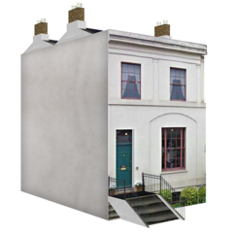

It is hard for many disabled people to find somewhere good to live.

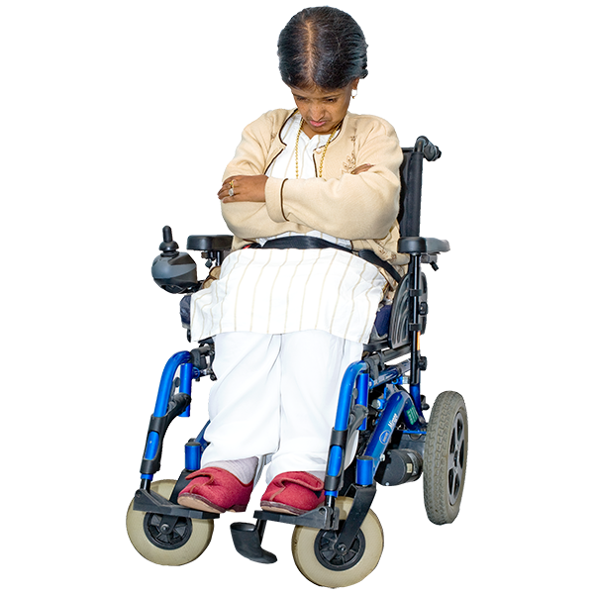
All of this can stop disabled people from having a good life.

Women

Women often work in jobs that pay less money.

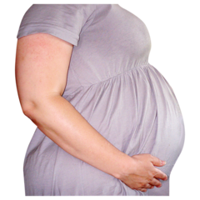
Bad things can still happen to many women at work.

For example, women may be bullied.

Or they may be treated unfairly because they are having a baby.

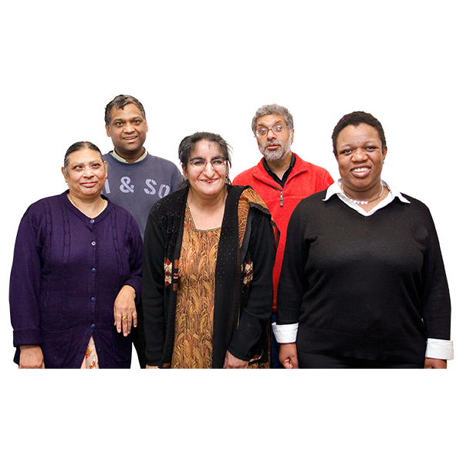
People from some ethnic minority groups

Your ethnic group means where you and your family are from and the language you speak.

Life can be harder for people from some ethnic minority groups.

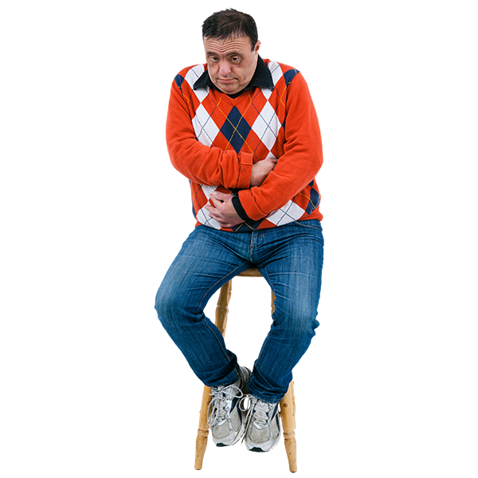
For example, people who are Black African, Pakistani, or from Gypsy, Roma and Traveller groups are more likely to be poor.

People from some ethnic groups are more likely to:

- Live in poverty with not much money

- Be treated badly or in an unfair way

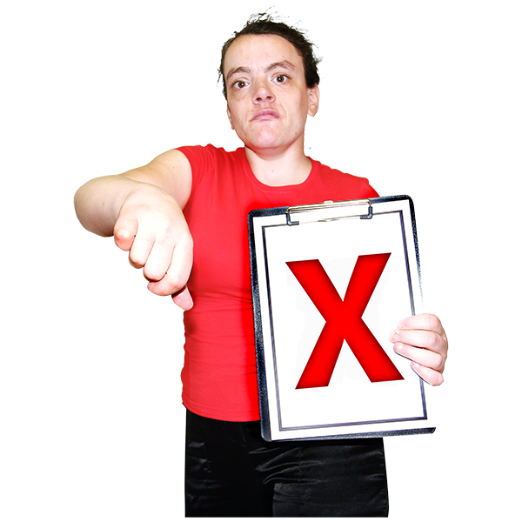
- Feel lonely.

Crime, police, courts and prisons

Some things have got worse since 2015.

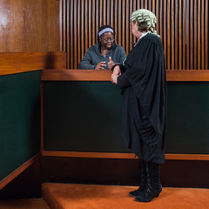
For example, it is harder for people to get help to go to court if they have been treated unfairly.

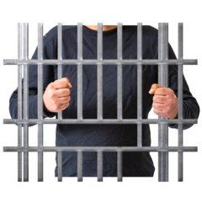
There are too many people in some prisons in Wales.

Some people are hurt or treated badly because of their
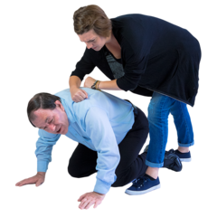
  - Disability
  - Religion
  - Race
  - Sexual orientation

This is called hate crime.

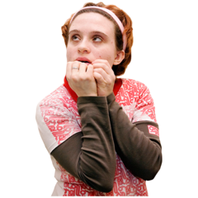
Hate crimes happen when:

- Someone tries to force someone else to do sexual things when they don’t want to

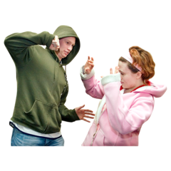

- Someone keeps hurting someone they are in a relationship with or someone in their family.

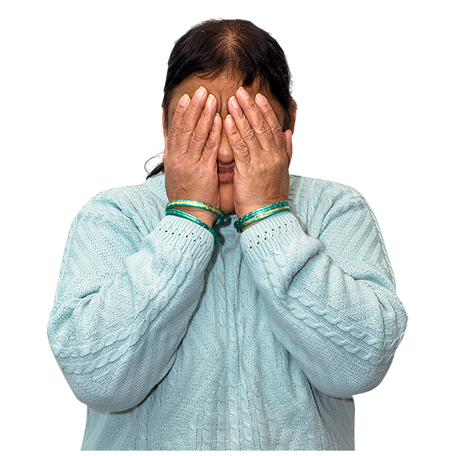
Crimes like this can happen to some people more than others.

For example, women and disabled people.

disabled people.

What should happen next

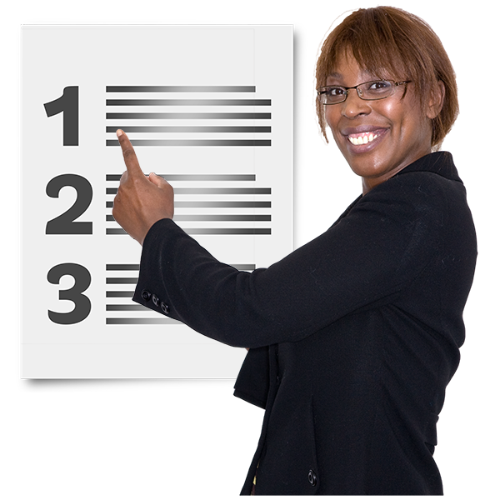

Here are some of the main things we want to happen next.

We will work with the Welsh Government and other people to do this.

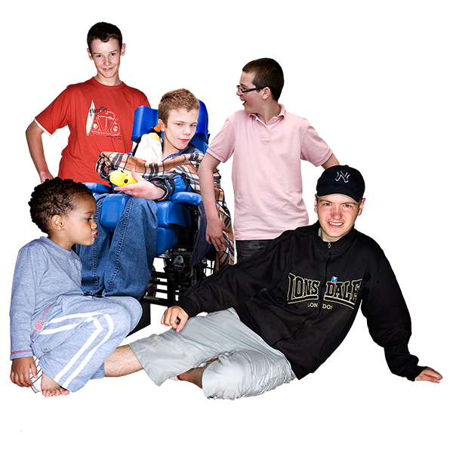

The Welsh Government should:

- Stop children being bullied and taken out of school

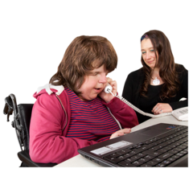
- Find disabled people, women and ethnic minority people better jobs and pay them fairly

- Make sure disabled people have a place to live

- Stop people being poor

- Make sure everyone can get good healthcare and treatment.

- More should be done to stop violence and people hurting themselves in prison

- Encourage more people to vote and stand in elections.
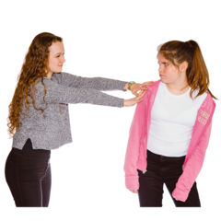

More must be done to make life fairer for women.

For example:

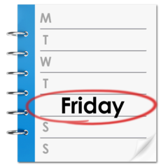
- Schools should do more to stop girls being hurt or treated badly.
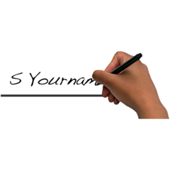
- Companies should do more to stop women being treated badly because they have a baby.

To find out more

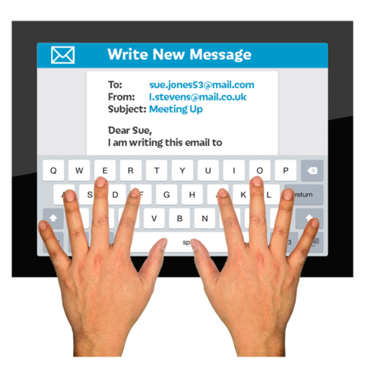

If you have any questions about this report you can email:

wales@equalityhumanrights.com

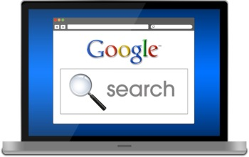
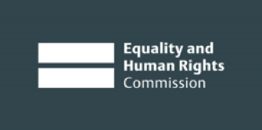
You can also go to our website at:
www.equalityhumanrights.com

If you want advice about being treated fairly, you can speak to the Equality Advisory and Support Service.
This service is free. You can get in touch by
Phone 0808 800 0082
Textphone 0808 800 0084

Pictures by Photosymbols

